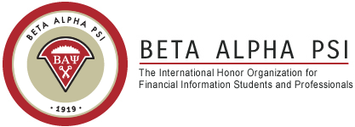

**Community Service Events**

***Spring 2017 Schedule***

|  |  |
| --- | --- |
| **Date** | **Event** |

|  |  |
| --- | --- |
| Saturday, February 18  9am - 1pm  Friday, March 3  9am - 1pm | Sawgrass Nature Center  3000 Sportsplex Center, Coral Springs  Boca Helping Hands  1500 NW 1st Ct., Boca Raton, FL |
| Saturday, March 4  9am - 1pm | 1720 Deerfield Island Park, Deerfield Beach, FL 33441 |
| Friday, March 17  9am - 1pm | Boca Helping Hands  1500 NW 1st Ct., Boca Raton, FL |
| Saturday, March 18  9am – 1pm  Saturday, March 25  8am – 10:30am | Sawgrass Nature Center  3000 Sportsplex Center, Coral Springs  Sea Angels at Ocean Inlet Park  6990 N. Ocean Blvd., Boynton Beach, FL 33435 |
|  |  |
|  |  |

*For more information about Beta Alpha Psi go to* <http://business.fau.edu/departments/accounting/student-resources/student-organizations/beta-alpha-psi/index.aspx#.WJqEkTsrLIW>

*For any further questions regarding Community Service Events, please contact Juan Carlos Pedraza   
(561) 215-8474 or email at* [jpedraza2015@fau.edu](mailto:jpedraza2015@fau.edu)*.*